UNIVERSITY COLLEGE DUBLIN
Graduate Research Programmes Leave of Absence Application Form
NOTE: This form should only be used where the time period for which you are applying does not appear to you in SISWEB¹

A leave of absence is defined as an extended period of time spent away from the programme of study. It is approved by the Graduate Board. Please contact your Principal Supervisor or School Office for programme specific information on whether it is possible to take a leave of absence from your programme.

As a student on a graduate research programme, you may apply for a leave of absence for a period of one, two or three terms.² In accepted extenuating circumstances you may apply for a leave of absence period equivalent to one term if the period of time requested spans two terms.

Since 1 August 2016, the application form for a standard leave of absence has moved to SISWeb and can be accessed under ‘Programme Services’ and ‘My Leave of Absence/Withdrawal Requests’. ²

Before submitting your application you are advised to seek advice and should contact your School/Programme Office. You should read the Graduate Programmes: Guide to the Leave of Absence Academic Policy, which is available at www.ucd.ie/leaveofabsence and make yourself aware of the possible implications for you of taking a leave of absence e.g. fees implications, campus entitlements.

You should submit your application in advance of your requested leave of absence. Your confidentiality is assured. Only those people who will consider and process your application will have sight of this form.

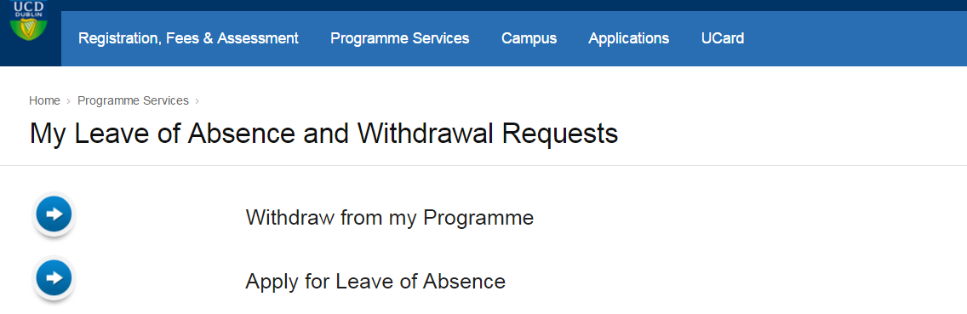

Paper form: all students complete Sections A – C. Section D is completed by the Principal Supervisor and Head of School and Section E is completed by the School and Graduate School Offices.

Notes
¹ A retrospective application for a leave of absence will only be granted by the Graduate Board in accepted extenuating circumstances cases where there is no other available solution for the student given their circumstances and where the student has not normally been engaged in any programme activity. In all retrospective applications, appropriate original supporting evidence must be supplied e.g. medical certificate. Please refer to the Guide on Completing the Leave of Absence Application Form (available at www.ucd.ie/leaveofabsence) for further information on what is accepted as appropriate original supporting evidence.
NOTE: original supporting documentation is not-returnable. It is recommended that you retain a copy of the application for your records.

² The total amount of leave of absence time that a student may be permitted to take over the course of the programme is at the discretion of the Graduate Board. The University recommends that the maximum amount of leave of absence time that may be granted is equivalent to 1/3 of the total length of the programme. Where a student requires more time, they are advised to seek advice (e.g. from the School Office) and refer to Section 8.5 of the Graduate Guide (“What options are available if a student needs leaves of absence for more than 1/3 of the total length of the programme?”).
- PERSONAL AND PROGRAMME DETAILS
Student Name
Student Number |  |  |  | Telephone Number  (Land & Mobile)
UCD Connect E-mail Address
Permanent Postal Address
Programme Title & Code
Name of Principal Supervisor
School |  |  |  | Date you commenced your programme | Month  Year
Period of Leave Requested  Please tick the appropriate duration and indicate the intended period of duration |  | ❑ One term OR  Two terms OR  Three terms  Date from: (month) (year)  Date to: (month) (year)
- REASONS FOR YOUR REQUEST
Please outline clearly the reason(s) for your leave of absence application.
Use an additional page appended to this form if necessary or you may provide relevant supporting documentation.

Note: retrospective applications must be accompanied by appropriate original supporting evidence e.g. original medical certificate. Please refer to the Guide on Completing the Leave of Absence Application Form for further information.
Have you previously taken a leave of absence from this programme? YES/NO
Where YES, please indicate below the dates of previous leaves of absence from this programme.
Date from: (month) (year)

Date to: (month) (year)

- STUDENT DECLARATION
I confirm that I am aware of and understand the possible implications of taking a leave of absence (please refer to www.ucd.ie/leaveofabsence). I confirm that I have read the Graduate Programmes: Guide to the Leave of Absence Academic Policy (available at www.ucd.ie/leaveofabsence) and consulted the Checklist located at the back of this form.

I confirm that I am aware of and understand that it is my responsibility to either 1/ re-register at the end of my leave of absence period or 2/ apply for a second leave of absence before the end of my first leave of absence period.

I confirm that to the best of my knowledge I am not involved in a pending disciplinary action.

The information given in this form is true and factually correct. I confirm that this information may be disclosed, where necessary, to academic and administrative staff of the University involved in determining and implementing my request.

Print name:

Signed:

Date:

- ADDITIONAL SIGNATURES REQUIRED
The following additional signatures are required.
In signing the completed form, the Principal Supervisor and Head of School are indicating their approval of the application.
Principal Supervisor:
Head of School:
- FOR OFFICE USE ONLY
- RECEIVED BY THE SCHOOL OFFICE
Office: Date:

Signed: Print name:

School Board Recommendation and Date:

- DATE SENT TO THE GRADUATE SCHOOL OFFICE (File copy)
Office: Date:

Signed: Print name:

- DECISION OF THE GRADUATE SCHOOL BOARD (File copy)

Application approved:  YES  NO

Date of decision:

Delegated Authority:
Date Registry informed of the approved leave of absence period (File copy)

Checklist for Students when making a leave of absence application

As a UCD student, it is your responsibility to seek advice if you are considering applying for a leave of absence. An up-to-date list of support systems can be accessed at http://www.ucd.ie/students/studentsupport.html and include your School Office, UCD Student Adviser, member of the UCD Access/New ERA or Disability Support Service staff, official UCD student counsellor, UCD Chaplain, UCD Students’ Union, UCD Student Desk, UCD International Office, your Principal Supervisor.

Have you spoken to any of the following?
- Your Principal Supervisor
- Your Doctoral Studies Panel
- Your School Office
- Your Graduate School Office
- Your Student Adviser
- The International Student Adviser (international students only)
- UCD Students’ Union Welfare Officer
- Other UCD support systems (as outlined above)

Have you read?
- The Graduate Programmes: Guide to the Leave of Absence Policy (available at www.ucd.ie/leaveofabsence)

Are you aware of the implications of taking a leave of absence with regard to?
- Fees
- Immigration issues (where applicable)
- Grants and payments under grants
- Student Programme Activity
- Student status and registration
- Your programme of research
- Campus entitlements, including UCD Residences

If you are in receipt of external funding, including grants:
- Have you spoken to your sponsor/funding agency?

If you are resident in UCD Residences:
- Have you spoken to UCD Residences?

Information about returning from a leave of absence that you need to be aware of before you make your application. Are you aware that:
- There may be implications on your return e.g. modules that were offered before and during your leave of absence period may no longer be offered when you return?
- You must inform your Principal Supervisor and School Office as early as possible and before the end of your leave of absence period of your intention to return to your programme or to apply for a second leave of absence (or withdraw)?
- It is your responsibility to confirm your re-registration via SISWeb when you return?
- There are implications of not confirming your re-registration (e.g. cancellation of registration)?
- UCD Registry will inform you of the re-registration process by sending an email to your UCD Connect account before the end of your approved leave of absence period. Are you aware that it is your responsibility to check your email in order to access this information?

